# Capacitive Soil Moisture Sensor V2.0

Circuit

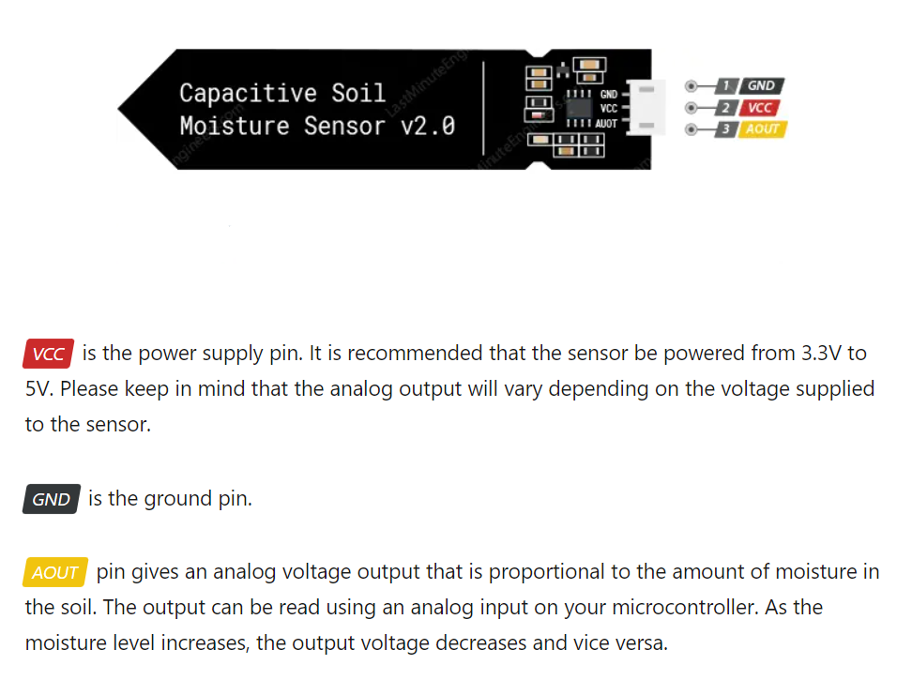

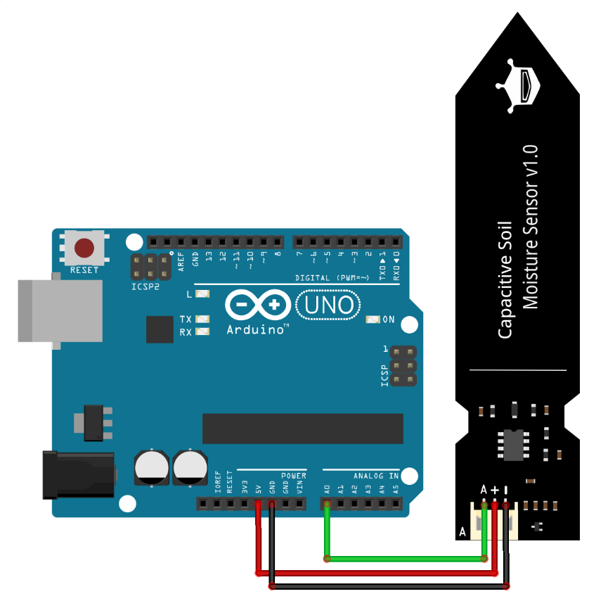

Setting Up

The sensor includes an on-board 3.3V voltage regulator, making it suitable for 3.3V and 5V MCUs. Plus, it consumes less than 5mA of current.

Note that this sensor can only provide a qualitative measurement of soil moisture. As the soil gets wetter, the output value decreases, and as it gets drier, the output value increases. When powered at 5V, the output ranges from about 1.5V (for wet soil) to 3V (for dry soil).

Testing

The Capacitive Soil Moisture Sensor V2.0 needs two calibration values to work since the capacitance varies with soil types. Connect the sensor with Arduino uno as in the diagram

After uploading the code use COM port or a TerraTerm to watch the port at 9600 baud rate.

**Finding Threshold Values**

1. Upload the threshold sketch to your microcontroller.

2. Record sensor output under the following conditions:

a. When the soil is dry enough that the plant needs watering (drySoi

b. When the soil has reached the ideal moisture level for the plant.

c. When the soil is heavily watered and is too wet (not ideal for the plant). (wetSoil)

3. Use the recorded values to establish moisture threshold ranges and modify them in the code “Soil_Moisture_caliberation”

It's recommended that the probe should not be placed at a depth which crosses the limit line on the sensor. The components on this board are NOT waterproof

/* Change these values based on your observations */

#define wetSoil 277 // Define max value we consider soil 'wet'

#define drySoil 380 // Define min value we consider soil 'dry'